Chapter 6, Solution 8.

(a) 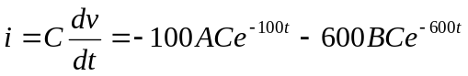 (1)

(2)
(3)
Solving (2) and (3) leads to
A=61, B=-11

(b) 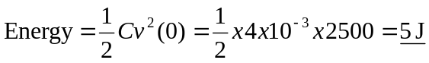

(c ) From (1),

